Business Process Automation System (BPAS)

Merit & Needs-Based Scholarship Program

Process Design Document
Customer | SFAO-University of Karachi
Project | Business Process Automation System (BPAS)
Process | Merit & Needs-Based Scholarship Program
Version | 1.1

Document Details
Document Information
Document Title |  |  | Process Design Document for Merit & Needs-Based Scholarship Program
Document Description |  |  | This document contains the business requirements and technical design specifications of Merit & Needs-Based Scholarship Program
Revision History
Version | Date |  |  | Description of Change |  |  | Author
Approval History
Version |  | Date |  | Name | Role | Signature |  | Comments

Table of Contents

Merit & Needs-Based Scholarship Program 1
Process Design Document 1
1. Introduction 6
1.1 Process Objective 6
1.1.1 Purpose 6
1.1.2 Scope of this process 6
1.2 Process Stakeholders 6
1.3 Definitions and Abbreviations 7
2. Business Process Details 8
2.1 Process Objective 8
2.1.1 Process Scope 8
2.1.2 Process Boundary 9
2.2 Sign in 10
2.3 Process Flow 10
2.3.1 Application Submission 10
2.3.2 Evaluation 10
2.3.3 Application approval 11
2.3.4 SAP integration (this Point will be discussed) 11
2.3.5 Accounts Follow Up 11
2.4 Process Overview 11
3. Dashboards 14
3.1 University Focal Person Dashboard 14
3.1.1 Dashboard Screen Design 14
4. APPENDIX B – EMAIL TEMPLATES 16
4.1 Email message to applicant after receiving online application 16
4.2 Deficiency of Documents (If any). Before interview, FAO verifies documents and email to applicant for the submission of the deficiencies in application 16
4.3 Call for Interview (For applicant appearance for interview before Institutional Scholarship Award Committee) 17
4.4 ISAC Decision (after the interview of applicants) 17
4.5 SMC Decision (Selection of candidates for scholarships) 17

Table of Figures

Figure 1: Login Screen 14
Figure 2: Focal Person Dashboard 18
Figure 3: ISAC Interview Scheduling Screen (1) 19
Figure 4: Interview Date selection 19
Figure 5: UFP adding ISAC Marks and Change Status 20
Figure 6: Invoice Details 20
Figure 7: Adding Invoice data 21
Figure 8: Admin Dashboard 22
Figure 9: Add Department 24
Figure 10: Add Discipline 25
Figure 11: Add Degree 26

Introduction

Process Objective
Merit & Needs-Based Scholarship Program’s ( MNBSP) objective is to automate all the activities mentioned below in this document which are currently manual as a part of Merit & Needs-Based Scholarship Program. -MNBSP automated system may consider any application from the entity (University) in order to get registered on Merit & Needs-Based Scholarship Program (IAP) to proceed further to avail the scholarships under the flag of Merit & Needs-Based Scholarship Program.

Purpose
This document contains the business specifications for ‘Merit & Needs-Based Scholarship Program’ process. Once this document is approved by the management team of University of Karachi it will serve as the definitive statement of scope and requirements for ‘Merit & Needs-Based Scholarship Program’ process for the MNBSP. Any modifications or changes to the requirements after document sign off will be handled via change control procedures.

Scope of this process
This descriptive document covers all the requirements of the Merit & Needs-Based Scholarship Program -MNBSP and this will be marked as finished on completion of scope defined in this document.

Process Stakeholders
The stakeholders associated with the process are:

S. No | Business Actor | Actor Type (e.g. Human, Sub-system, External Device) | Function / Business Actor Goal
 | Applicants | Human | Students can perform following operations:  - Save application form  - Edit application form  - Submit scholarship application form  - View the status of submitted Application
 | University Focal Person (UFP) | Human | UFP can perform following operations:  - View status/details of applications.  - Filter data.  - Print app form.  - Provide information / Summary of students’ academic performance.  - University focal person reporting.  - Budget, finance, funds reporting.  - Invoice generation.  - Edit Application forms  - Submit applications on behalf of students.  - Update ‘For Office Use Only’ section in application form.  - Evaluate applications as per defined weightage criteria.  - Pre-ISAC evaluation.  - Schedule interviews for shortlisted candidates.  - Inform students and ISAC members about interview schedules.  - Update Interview results in system  - Perform physical evaluation  - Generate Excel sheet which can be used to generate controlled documents. (Format will be provided by UNIVERSITY )  - Get ISAC interviews conducted  - Record ISAC interview results  Can generate Excel sheet to be presented in ISAC
 | UNIVERSITY Super Admin | Human | Super admin role details mentioned in 2.1.1.3

Definitions and Abbreviations
Abbreviation | Description
UNIVERSITY | Higher Education Commission
UFP | University Focal Person
ISAC | Institutional Scholarships Award Community
SMC | Scholarship Management Committee
SMU | Scholarship Management Unit
MNBSP | Merit and Need Based Scholarship Program

S. No. | Task | Actor | Description |  | Status
 | Submit ‘Merit & Needs-Based Scholarship Program’ application. | Human  (Applicant) | Applicant logs into portal using common profile credentials and submits the ‘Merit & Needs-Based Scholarship Program’ application form through portal. | Candidates’ status ‘APPLICANT’
 | Send email notification to applicant | System | An email notification is sent to the applicant upon receiving online application.  Please refer Appendix B -
 | Start Evaluation | System | Preset scoring weightage criteria will be executed. All submitted applications will be scored against the configured weightage.
 | UFP Approval task. | UFP | UFP selects N students by "Top Score" + "Monthly Income" filters students based on University's quota + Waiting list  UFP also verifies applicant’s documents and inform applicants in case of a deficiency. Refer Appendix B section 4.2
 | Pre-ISAC Evaluation | UFP | UFP performs pre-ISAC evaluation to filter down the list of applicants who will be considered for the ISAC interviews. This step is optional and is only performed in case there is a large number of scholarship applicants.
 | ‘Recommended’ | UFP | Top N 1 student’s number equal to university Quota will be selected as ‘Recommended’.  Students are informed via email Refer Appendix B section 4.3 | N1 students’ status will be ‘RECOMMENDED’
 | ‘Waiting’ | UFP | Top N 2 student’s number equal to recommended students will be selected as Waiting.’  Students are informed via email Refer Appendix B section 4.3 | N2 students status will be ‘WAITING’
 | ‘Rejected’ | UFP | All remaining applicants will be updated with Rejected status. | Remaining applicants’ status will be ‘REJECTED’
 | ISAC committee Results - Recommended | ISAC | ISAC interviews the Recommended applicants by UFP and further filters down the applicants. Those who qualify would be updated as ‘Recommended’.  Recommended applicants are informed via email. Refer Appendix B section 4.4 | Students status changed to ‘Recommended’
 | ISAC Committee Results - Rejected | ISAC | ISAC interviews the Recommended applicants by UFP and further filter down the applicants. Those who would not qualify would be updated as ‘Rejected’ | Students status changed to ‘Rejected’
 | ISAC Committee Results - Waiting | ISAC | ISAC interviews the Recommended applicants by UFP and further filter down the applicants Similar number of applicants as in Recommended status are updated as ‘Waiting’. | Students status changed to ‘Waiting’
 | SMC Committee Results | PMU | PMU waits for each university to submit their ISAC scores so that they evaluate them altogether in SMC meeting.
- a. | SMC Committee Results – AWARDEE | PMU | Successful applicants are updated with ‘AWARDEE’ status  Approved candidates are informed via email. Refer Appendix B section 4.5 | Students status changed to ‘AWARDEE’
- b. | SMC Committee Results – Reject Candidate | UNIVERSITY - | Applicants failing to pass SMC meeting interviews are updated with ‘REJECTED’ status | Students status changed to ‘REJECTED’
 | ‘Physical Verification’ | UFP | UFP conducts physical verification of each awardee status.
 | ‘Physical verification Result - REJECTED | UFP | Students failing Physical are updated with ‘REJECTED’ status. | Students status changed to ‘REJECTED’
 | Inform Applicants | System | System sends email notification to UFP and students regarding funds disbursement.

Business Process Details

Process Objective
Automation of accreditation system initiated to provide ease for all stakeholders associated with it.
Automation of accreditation benefits by simplifying your operational environment. It reduces the amount of manual intervention required to manage operations. The other objectives of the MNBSP system’s automation:
- Improved system reliability and transparency.
- Increased process speed and quality.
- Lesser effort of human factor to process.
‘Merit & Needs-Based Scholarship Program’ (Merit and Need Based Scholarship Program) process aims to facilitate UNIVERSITY – , University Focal Persons (UFP) at partner universities, Scholarship Management Committee (SMC) and applicants to better manage and streamline different activities and tasks associated with ‘Merit & Needs-Based Scholarship Program’.
With the help of automation of this process, we aim to reduce the process completion period and eliminate the hassle of manual handling of scholarship applications and duplication of efforts from HR department over a period of time. Moreover, each applicant would be analyzed in a more particular way with lesser number of failures.

Process Scope

Applicants / Students
The Merit & Needs-Based Scholarship Program process portal integration with application form which allows the applicants to initiate Scholarship application request (already developed and live).

Partner Universities (Focal Person)
Currently the Merit & Needs-Based Scholarship Program has 29 local universities in its panel. List of universities will be provided by UNIVERSITY . Universities has several degree programs under it for which the scholarships are being offered so the list of programs will be provided by UNIVERSITY . Focal person dashboard will have the functionality of print the application forms, view list of applicants with details of specific university, add ISAC marks, approve or reject application,
As evaluation starts system will restrict submission of any further applications and will create a task for UFP. UFP user will evaluate each and every application according to the defined weightage criteria. UFP will select top N students based on university/program quota and the weightage criteria and forward the cases of shortlisted candidates to ISAC for interviews. UFP may also perform a Pre-ISAC evaluation if required. UFP will also inform the students of interview schedules with ISAC via emails and phone calls (if needed). The status of the shortlisted applicants will be updated to ‘SHORLISTED’.
After ISAC interviews the grading or marks entered into the system for each applicant along with the necessary comments/remarks. Each applicant is given either a ‘RECOMMEDED’, ‘WAITING’ or ‘REJECTED’ status before they are forwarded to the SMC. UFP user/ISAC user feeds the data on screen as per each student’s score and status.
PMU on other hand waits for all universities to submit ISAC scores before proceeding further. It generates an excel sheet having schedule of interviews with the SMC along with a report intended for the SMC containing the tabular data with statistics related to the scholarship slots. Applications will be forwarded to Scholarship Management Committee (SMC) consisting of ‘RECOMMENDED’ students once these prerequisites are met.

UNIVERSITY Super Admin
MNBSP System provides flexibility to configure the “Batch” with ‘Scholarship Start Date’ and ‘Scholarship End Date’ with batch date extend functionality and intimate email the applicants and University Focal Persons (UFP) users, 1 week before scholarship end date to fill in and submit the application form. System also allows process admins to configure the criteria (criteria fields like: age, education, program etc. will be provided by UNIVERSITY ) for the scholarship eligibility evaluation task. Standard data filter functionality will be available in admin dashboard. Its configurable in the system at admin screen to add or remove university and is not limited to the current number of institutions which means admin can add new universities and remove universities from the existing list. Moreover, each university not necessarily follows a uniform policy of academic year which is why some scholarships are needed to be offered based on the annual system while others based upon the semester (fall and spring) system.
SMC will analyze each application and instances of approved students will be forwarded to the UFP which will conduct physical verification meeting for further evaluation. If candidate is rejected in the process, then ‘Rejection Remarks’ will be entered into the system with “rejected” status whereas for successful candidates the status of the applicants will be updated to ‘AWARDEE’. Process is then assigned to PMU user for SAP Integration and PMU user waits for control documents to be sent by UFP through surface mail. Information of ‘AWARDEE’ students will be fed into SAP through integration. The whole process ends here and a history sheet is generated and universities will be intimated by the Finance Department about the checks. If candidate is not promoted to the next semester, candidate’s status will be updated to ‘DROPPED’. If candidate skips a semester the status of candidate will be updated to ‘FREEZE’. Finance mechanism (tracking and management), budget allocation, amount distribution, amount cheque upload etc will be part of admin portal. Academic performance of students

Process Boundary
The process will maintain the Merit & Needs-Based Scholarship Program application cycle and application notifications along with the following applicants / candidate statuses:
- Applicant
- Recommended
- Awardee
- Rejected
- Freeze
- DROPPED
- PROMOTED

Sign in
Sign-in credentials will be created from backend as per the defined role. Sign in procedure will be same as scholarship portal with standard features. Sign in credentials will lead the user to their respective dashboard.

Figure 1: Login Screen

Screen details
Standard Log in features will be present in the system which includes the following:

- Log in
  - Check for correct CNIC
  - Check for correct password
  - Check for locked account
  - Check for blacklisted account

Process Flow
Process workflow is divided based on status of applicant. Currently process will support the statuses as mentioned in earlier in the Process Boundary section.

Application Submission
  - The application can be submitted by common profile registered student (on behalf of student, UFP user can submit and/or create using online Application form).
  - Applicant status will be updated to ‘APPLICANT’.

Evaluation
  - Application evaluation involves application review and compliance in accordance with the weightage criteria defined in the system.
  - Filtering of applications as per defined filter criteria
  - Selection of top N students eligible for scholarship
  - Interview with ISAC
  - Screening of applications by SMC
  - Physical verification by UFP

Application approval
  - The approval will involve ISAC and SMC.
  - Institutional Scholarship Award Community can choose to either
    - Recommend: ISAC representative/UFP will update information in the system and applicant status will be updated to ‘RECOMMENDED”. Remarks will also be saved.
    - Not Recommend: ISAC representative/UFP will update information in the system and applicant status will be updated to ‘NOT RECOMMENDED”. Remarks will also be saved.
  - The Scholarship Management Committee can choose to either:
    - Approve: SMC representative will update the information in System and applicant status will be updated to ‘AWARDEE’. System will generate working paper. SMC will sign Working paper.
    - Reject: SMC representative will update the information in System and applicant status will be updated to ‘REJECTED’. Rejection remarks will be saved in the system.

Accounts Follow Up
  - Based on accounts/finance follow up and decision, the application is either:
    - Approved: SAP user accepts the application.
    - Rejected: SAP user rejects the application based.

Process Overview
S. No. | Description | Actor | Misc.
 | Applicant logs on to the portal using his/her common profile credentials and accesses ‘ Merit and Need Based Scholarship Program’. Applicant fills and submits scholarship form. Applicant’s details will be saved in the database and status of applicant will be set to ‘APPLICANT’ | Students of various local universities | Applicant can only submit the application if he / she has submitted admission forms. Once an application is submitted, only UFP or UNIVERSITY user can edit it.
 | UFP/UNIVERSITY starts evaluation of submitted applications forms using Evaluation screen. | UFP/UNIVERSITY user | Once Evaluation process starts, no new forms can be submitted for same scholarship and current submitted forms will not be editable.  This step can be processed multiple times since the scores might get changed until the user proceeds to the next step
 | A score is calculated against the given criteria for each applicant based on configured weightage criteria. | System
 | UFP checks for each applicant’s score against the given criteria. Each applicant is updated with either a ‘Recommended’ or ‘Rejected’ status.  UFP can choose to start evaluation of all applicants again for possible changes in scoring criteria. | UFP user
 | After evaluation and scoring, the results would be visible to UFP. UFP can filter the students on basis of top score and monthly income. | UFP user
 | The UFP can also perform a Prer-ISAC evaluation to further filter down the list of students recommended for ISAC. This step is optional and is only performed incase a large number of applicants have applied for the scholarship. | UFP User
 | UFP recommends N number of applicants to ISAC for interviewing and prepares a schedule for interviews.  This N number will be configurable.  An Excel sheet will be exported to be presented in ISAC. | UFP User
 | ISAC meeting body will be created and list of students will be selected to be presented in that meeting. Interview schedule emails will be generated to be sent to Applicants. | UFP user
 | After Interview, Similar number of students as in RECOMMENDED status are categorized under ‘Waiting List’ by the UFP. Remaining applicants in excel sheet will be rejected. | UFP user
 | An email would be generated based upon the recommended applications by UFP which would be sent to ISAC Committee and applicants. UFP also intimates the applicants about their respective schedules via email (or phone call if needed) | UFP user, System
 | ISAC interviews the recommended applicants and assigns statuses ‘Rejected’ or ‘Recommended’. Remaining will be ‘Waiting’ as they were. | ISAC
 | UFP/ISAC user enters the data of the applicants (related to their scoring) in the database. And also manually sends the generated excel sheet with the names of the applicants who fall under ‘Recommended’ or ‘Waiting’ to SMC. | UFP/ISAC user
 | PMU waits for all universities to submit their ISAC scores to them before they begin creating meeting schedule with the SMC to discuss all the submitted cases. PMU prepares a meeting schedule for the SMC to discuss all the recommended cases which is shared with them. | PMU user
 | PMU generates a final excel sheet of applicants consisting of their scores (inclusive of their interview scores). This will be exactly same sheet which is printed by UFP after adding ISAC interview results. | PMU user
 | SMC meeting is held with the PMU and all possible cases are discussed in detail with the help of the report and excel sheet prepared by the PMU . Final decision of selection is taken in this meeting. The results are then forwarded to UFP consisting of applicants having either ‘Awardee’ or ‘WAITING’ status. Excel sheet of applicants will be printed that will be forwarded to UFP for AWARDED and WAITING applicants as decided by SMC. | SMC/PMU user | Those applicants which fall under ‘Recommended’ or ‘Waiting’ are analyzed only. SMC hold the right to discard any applicant from the ‘Recommended’ and select another from the ‘Waiting’ list.
 | UFP conducts the physical verification using Physical Evaluation Performa of the approved candidates. Final list of Awardee students is prepared. | UFP user | Control documents consisting of Awardee students goes through filters imposed by SMC, ISAC, Scholarship Session and Status Filter (promoted, freeze, not promoted or dropped)
 | PMU upon receiving control documents from UFP integrates students’ data with SAP | PMU user | Each student is allotted with a SAP number along with an invoice which is generated based upon its SAP Number.
 | Email alerts are sent to UFP and all students regarding disbursement of funds. | System | Process for each applicant ends at this stage.

Dashboards

University Focal Person Dashboard
University Focal person dashboard is the first/landing page where he will perform task: view all applications of specific university and print application forms as well. Design of the Focal person dashboard is as follow:
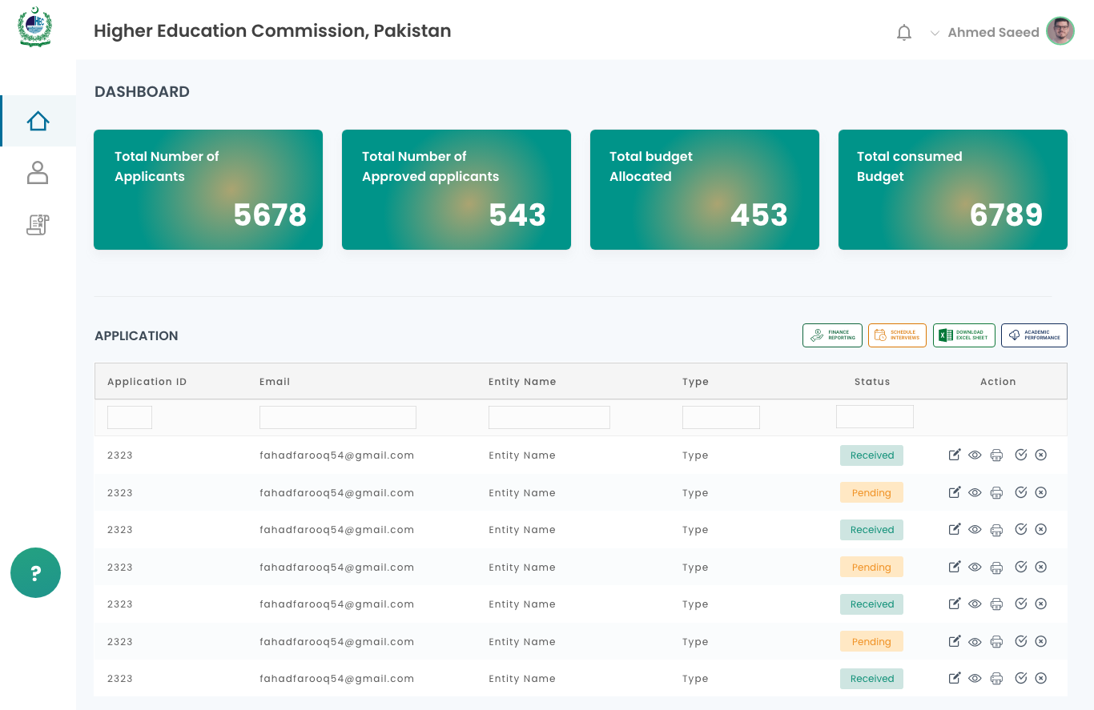
Figure 2: Focal Person Dashboard

Dashboard Screen Designs
Dashboard is where UFP will perform administrative tasks. UFP conduct ISAC interviews by scheduling via built-in calendar. Multiple interviews can be conducted in a day. UFP can also search for a list of students based upon Discipline and Batch No search parameters. UFP will select applicants from the list of students and schedule an interview on a specific date using schedular. System will automatically generate email and SMS to applicants who are eligible/fulfilling the criteria for ISAC interview. Design of screen is as follow:
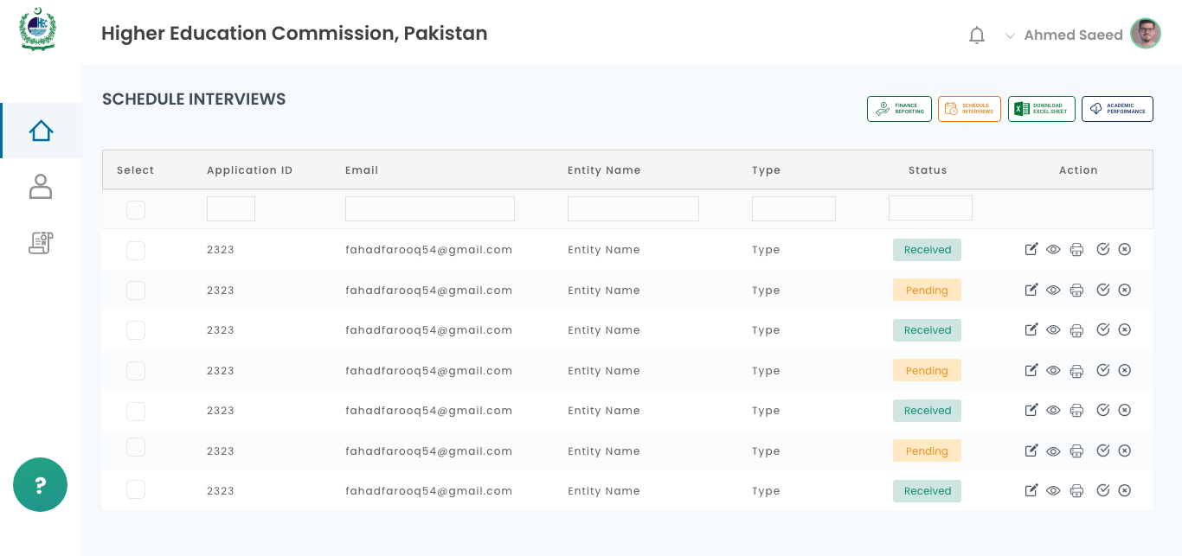
Figure 3: ISAC Interview Scheduling Screen
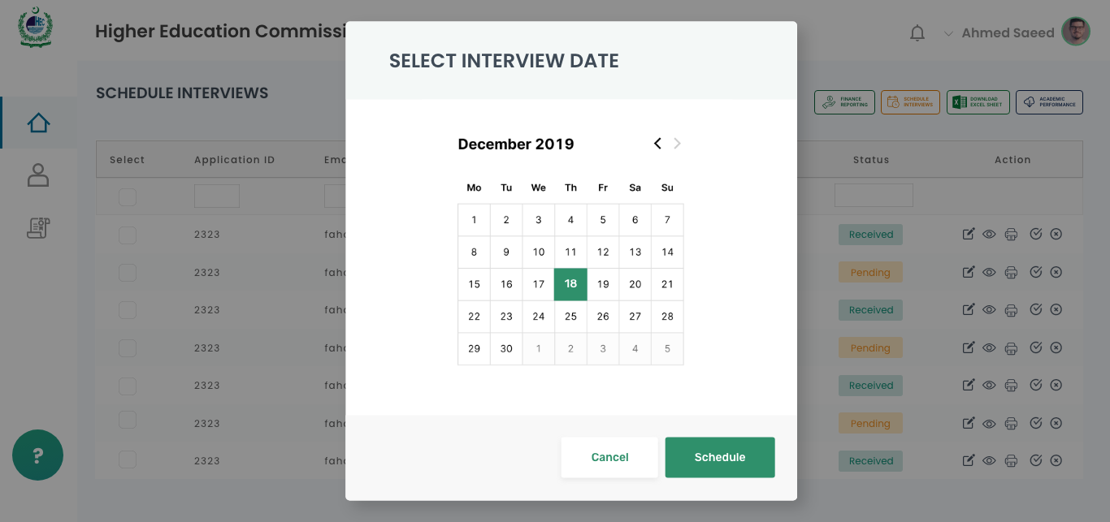
Figure 4: Interview Date selection
Add ISAC interview marks against each student scheduled for interview. UFP is responsible for add marks to the list of students. Change the status of applicants to “recommended” or “Not Eligible/Rejected”. Screen design is as follow:
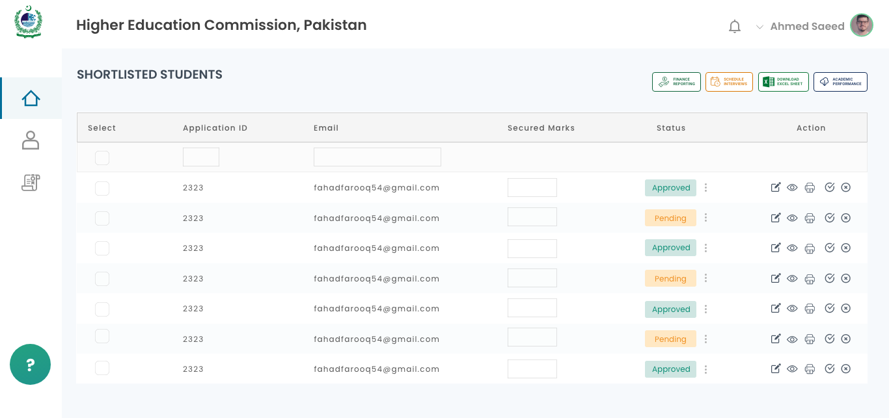
Figure 5: UFP adding ISAC Marks and Change Status
UFP will add all the finance details that includes fee details and other expanses of each student. UFP can generate the invoice of all students of a specific program/semester in a single batch on described template, attached below.
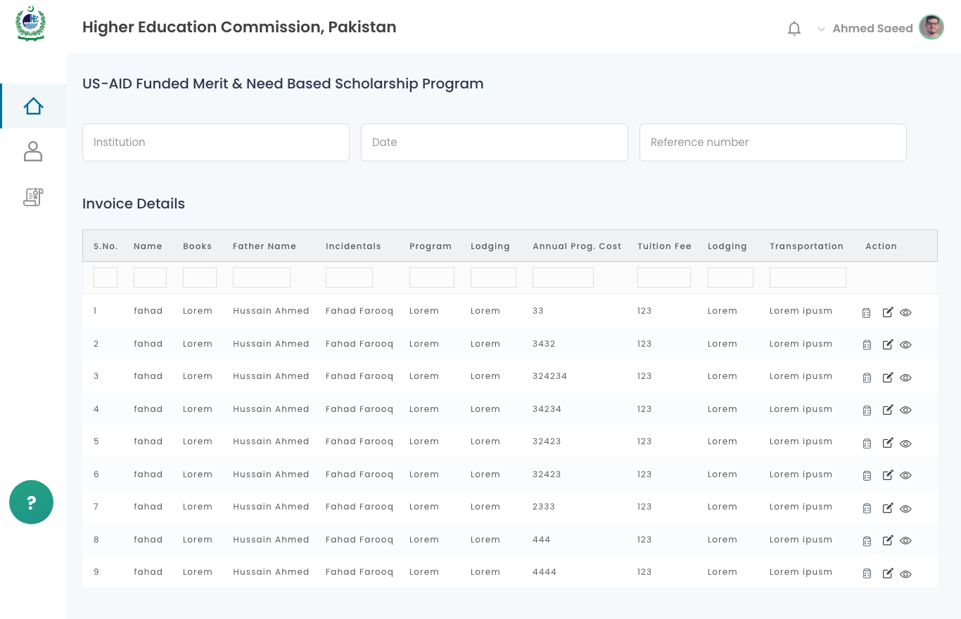
Figure 6: Invoice Details
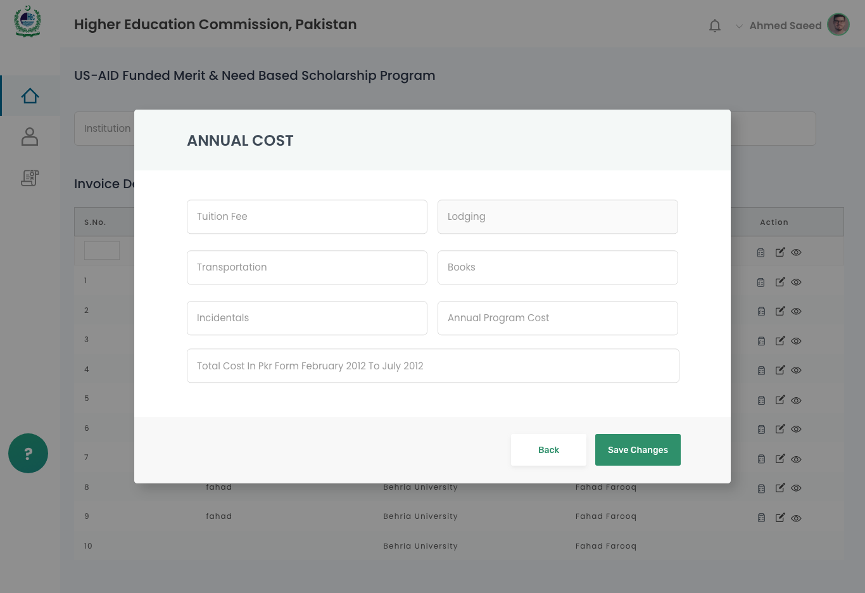
Figure 7: Adding Invoice data
Finance history will be maintained as a part of system & each students financial inventory will be maintained and updated on each finance iteration. Finance reporting mechanism on described format, attached below will be the part of the portal.

Academic Performance Screen Details
UFP will be have to provide the academic performance details of each student on specific format provided by UNIVERSITY as follow:
UFP provide CGPA details of each semester & enter remarks of each student which is awarded scholarship. Same as finance the history of academic performance will be maintained. UFP will add academic details using screen for it same as UFP entered finance details.

Academic Performance Screen Design

Physical Verification
The physical verification module will be added to enable the UFPs to add the results of the physical verifications of their students that are conducted at their respective universities. The UFPs can upload multiple physical verification results documents against a single batch.

Screen Fields
Field Name | Field Type | Validation | Description
Batch No. | Dropdown | Mandatory | Batch no. against which the physical verification document is to be uploaded.
Title | Dropdown | Mandatory | Title of the scholarship program for which the physical verification was conducted.
Upload Document | Button | Mandatory | Excel file containing the results of the physical verification of students will be uploaded by the UFP.

UNIVERSITY Admin Dashboard
UNIVERSITY admin dashboard is the main window to perform administrative tasks.
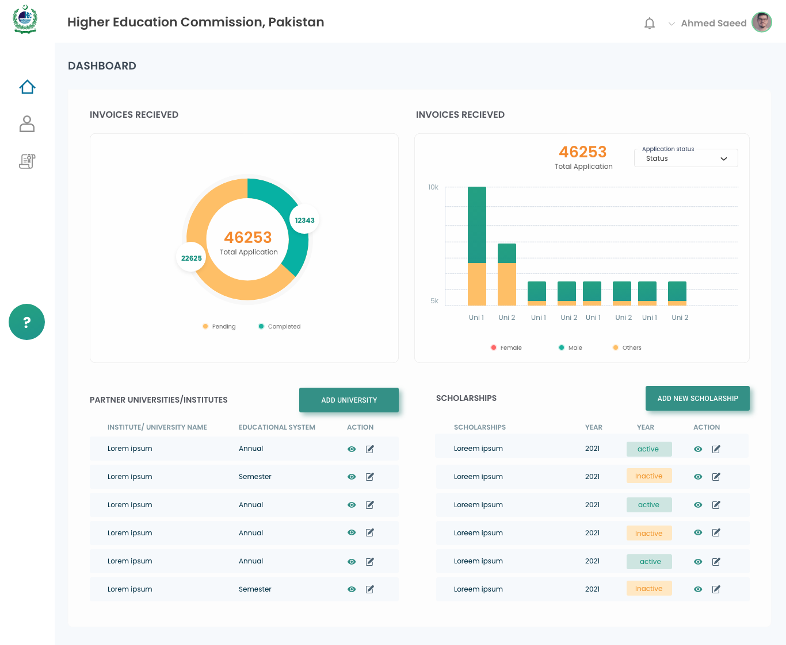
Figure 8: UNIVERSITY Admin Dashboard

Admin Screen Design
View stats related to scholarships i.e. Total applications, Total applications from specific university, batchwise scholarships etc. There are “add university” button, “Add new scholarship” button which will open respective windows to insert University data and create new scholarship. Admin will also be able to search for applications by CNIC, applicant name, university or batch.

UNIVERSITY Admin University Window Screen Details

UNIVERSITY admin will transverse to the new window “University Window” where admin can perform university related tasks. Screen details are as follow:
S. No | Business Actor | Actor Type | Function / Business Actor Goal
1 | Select Batch | Dropdown | Options of batches
2 | University Name | Drop down | Name of US-AID Partner Universities
3 | Add University | Button | Perform designated task
4 | Add Degree / Program | Button | Perform designated task

UNIVERSITY Admin University Window Screen Design
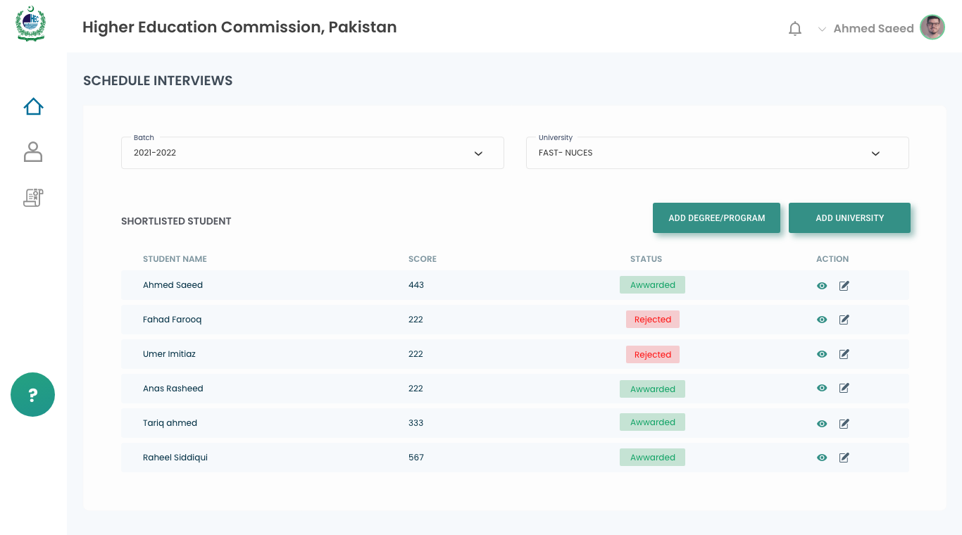
Figure 9: University Configuration Screen

Add University / Institute Screen Details
On University Configuration the names of registered universities and institutes will be fetched from the database and displayed. An option of further extending the list of registered institutions can be availed by navigating to the ‘Add Institute/University’ button. Likewise various degree programs can also be added or edited.

S. No. | Action | Description
1 | Search | This will allow the user to search the name of the institute typed in the search field provided adjacent to this button
2 | Add Institute/University | Admin clicks on the ‘Add University/Institute’ button and a new dialogue box would be opened which will have the fields relevant to register an institute in the database.
3 | Name of University / Institute | Admin clicks on the ‘Add Degree/Program’ button and a new dialogue box would be opened which will have the fields relevant to register a program within an institute in the database.
4 | Education System | Dropdown option will be “Semester Systems” “Annual Systems”
5 | Add | Admin clicks on the ‘Add’ button and this will insert the typed name of the institute and educational system in ‘Add Degree/Programs’ pop up.
6 | Cancel | Admin clicks this button to close the ‘Add University/Institute’ dialogue box and will return the user to the previously displayed screen.

Add University / Institute Screen Design
New partner university can be added by pressing “Add University” button and enter the details on the specific screen for adding university. The required fields to be filled by admin are as follow:

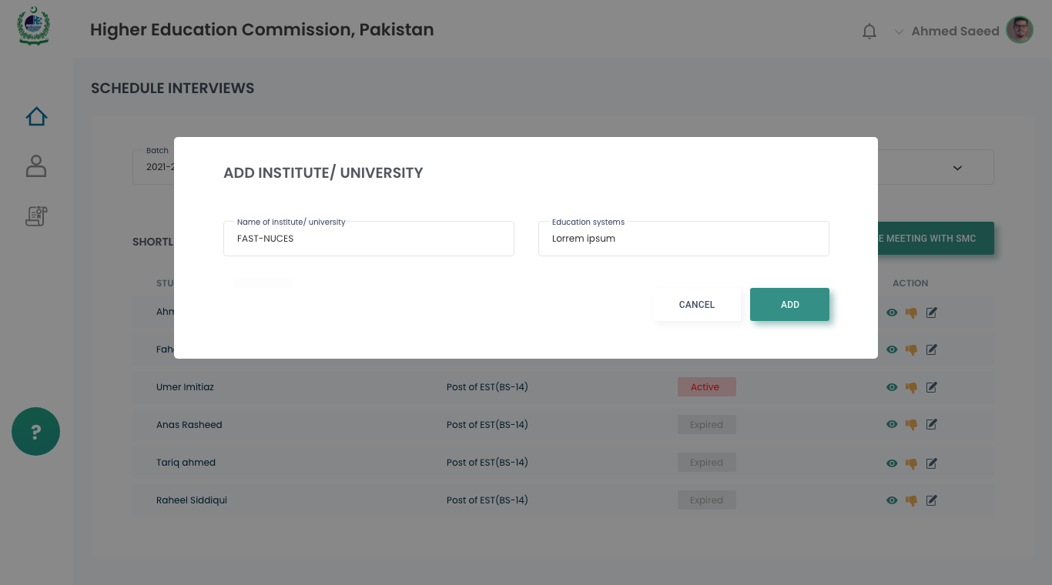
Figure 10: Add University

Add Discipline Screen Details
S. No. | Action | Description
1 | Search | This will allow the user to search the name of the discipline typed in the search field provided adjacent to this button.
2 | Add New Discipline | Admin clicks on the ‘Add New Discipline’ button and a new dialogue box would be opened which will have the field relevant to register a new Discipline in the database.
4 | Add | Admin will click on the ‘Add’ button to insert the typed name of the discipline into the relevant table of disciplines present in the database.
5 | Cancel | Admin clicks this button to close the ‘Add Discipline’ dialogue box and will return the user to the previously displayed screen.

Add Discipline Screen Design
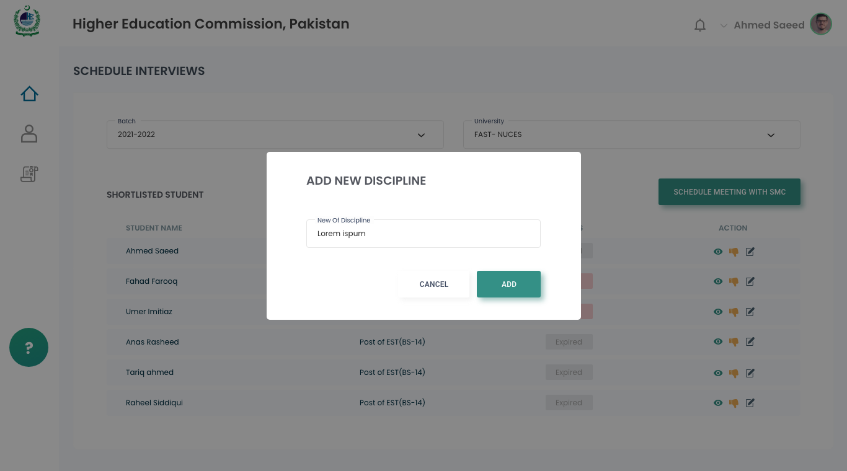
Figure 11: Add Discipline

Add Program / Degree Screen Details
S. No. | Action | Description
 | Search | This will allow the user to search either by ‘Discipline’ OR ‘Degree/Program’.  The results will be displayed in grid in following columns:  - Discipline  - Degree/program  - Actions
 | Add New Degree/Program | A new dialogue box would be opened which will have the field relevant to register a new Degree/Program under a Discipline.
 | Add | Admin will click on the ‘Add’ button to insert the typed name of the Degree/Program under the selected name of the Discipline into the relevant table of Degree/Program present in the database.
 | Cancel | Admin clicks this button to close the ‘Add Degree/Program’ dialogue box and will return the user to the previously displayed screen.

Add Program / Degree Screen Design
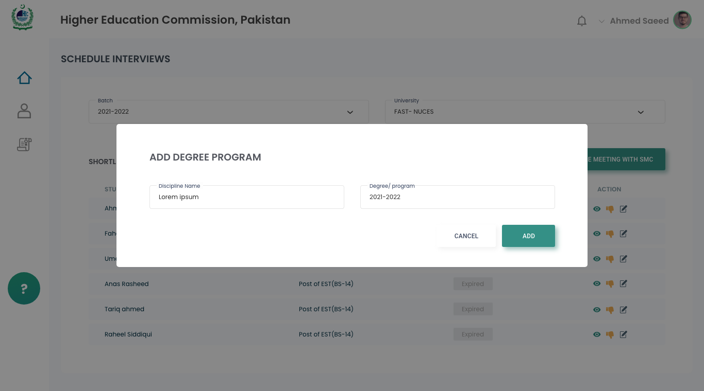
Figure 12: Add Degree
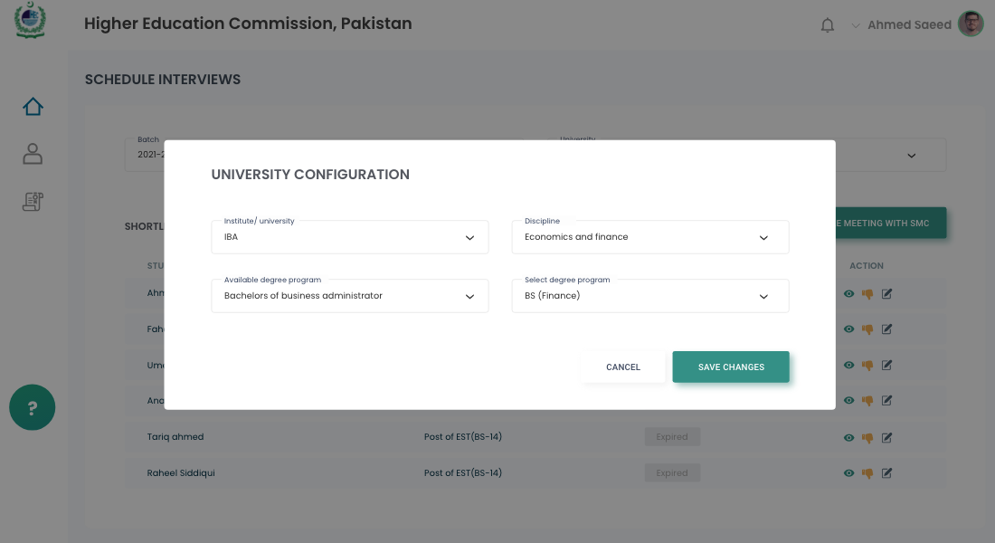
Figure 13: Add Program

Add New Scholarship Screen Details

S. No. | Action | Description
 | Scholarship Configuration Screen | This screen will be accessed by the admin when he/she access ‘Configure Scholarship’ from the admin panel.
 | Search | Admin clicks the ‘Search’ button which filters the results from the database on the following basis:  - Scholarship Title  - Institute/University  The results will be displayed in grid with following columns:  - Scholarship Title  - Institute/University  - Allowed Quota  - Remaining Quota  - Status  - Actions
 | Add New Scholarship | Admin click the ‘Add New Scholarship’ button which will enable the adding up a new Scholarship. The screen is going to have the following fields:  - Scholarship Title – Text Input  - Total Quota – Numeric Field (validation: the value cannot be a negative integer)  - Remaining Quota – Numeric Field (validation: cannot contain a value more than the Total Quota and it can neither be a negative integer)  - Scholarship Start Date – Calendar input  Scholarship End Date – Calendar input.
 | Add Record | Admin clicks the ‘Add’ icon to open up a new row in the grid for record entry. Following fields can be entered in the grid  - Scholarship Title - Dropdown  - Institute/University – input field  - Allowed Quota - Numeric Field (validation: the value cannot be a negative integer)  - Remaining Quota  - Status
 | Edit | Admin clicks the ‘Edit’ button which will enable editing the selected record.

Add New Scholarship Screen Design
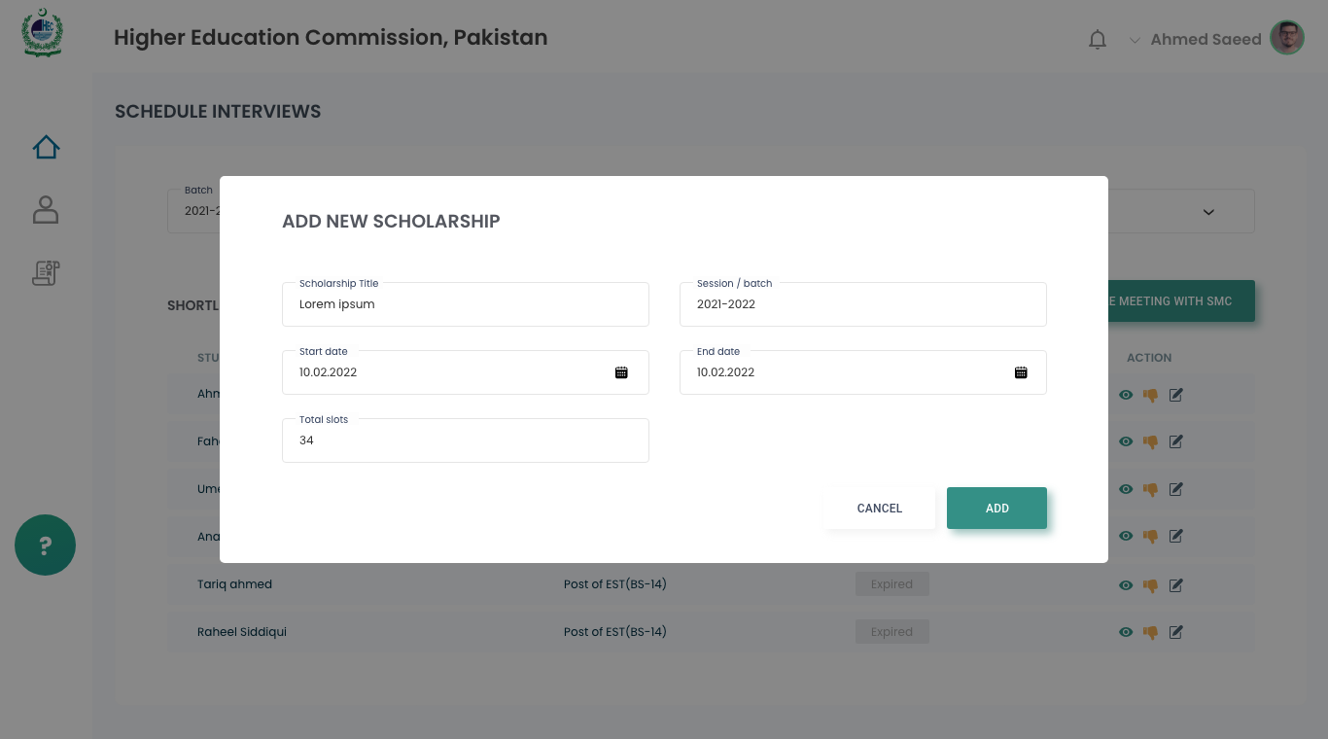
Figure 14: Add New Scholarship

Scholarship Quota Program Screen Details
This screen allows configuring scholarship quota for a particular Degree/Program of a particular university.

S. No. | Action | Description
1 | Scholarship Programs Screen | This screen will be accessed by the admin when he/she clicks ‘Add Programs’ button against a particular record in ‘Scholarship configuration grid’.
3 | Scholarship Programs. | On clicking ‘Add Program’ button system opens the Scholarship Programs screen with following controls:  - Institute /University Name – Read only  - Discipline – Dropdown control  - Degree/Program – Dropdown control  - Search button  - Add Programs button  - Grid control with following columns:  - Institute/University Name  - Discipline  - Degree/Program Name  - Program Quota - Editable  - Status - Editable  - Actions  - Actions
2 | Screen Control | Admin clicks the ‘Edit’ button to edit a listed program.  Admin clicks the ‘Delete’ button to delete a program from the list.  Admin clicks the ‘+’ button to add a new entry into the data grid.

Scholarship Quota Program Screen
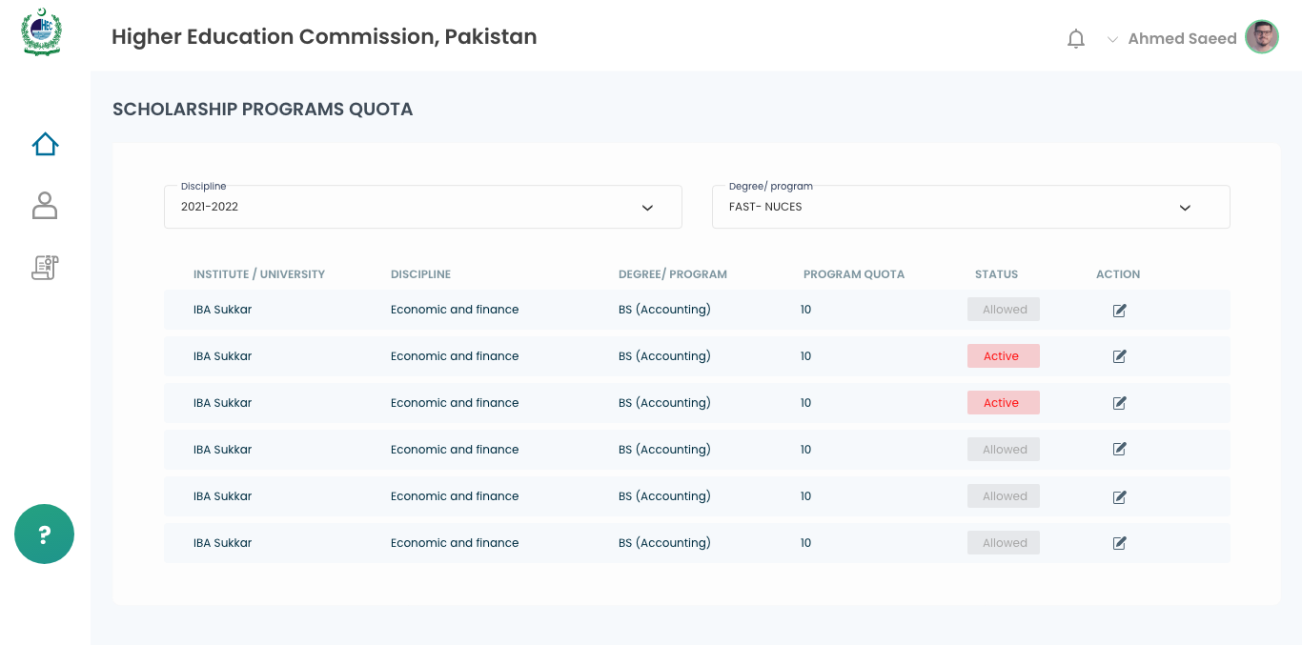
Figure 15: Scholarship Quota

Scoring Criteria Screen Details
Admins can configure scores for each of the defined weightage criteria.

S. No. | Action | Description
 | Scoring Criteria Configuration Screen | This screen will be accessed by the admin when he/she accesses ‘Scoring Criteria Configuration’ from the admin panel.
 | Search | Admin can search scores against each item of weightage criteria by using following available filters:  - Criteria – Dropdown Menu  - Item – Dropdown Menu  Weightage criteria and their respective scores are displayed in the grid under following columns:  - Criteria – Read only  - Item – Read only  - Score – Editable input field (AJAX feature)

Scoring Criteria Screen Degree
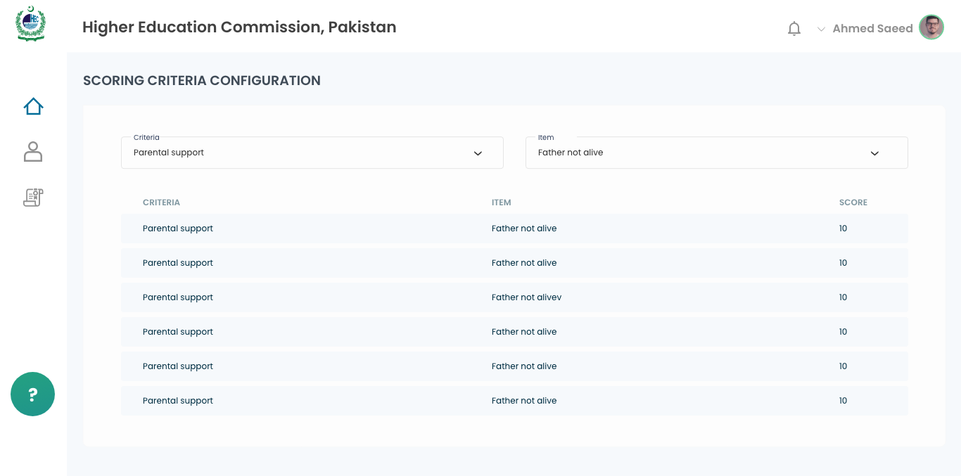
Figure 16: Scoring Criteria Configuration

Schedule SMC Meeting Screen Details
S. No. | Action | Description
 | Schedule Meetings Screen | This screen will be accessed by the admins when he/she clicks ‘Schedule Meeting’ from the admin panel.
 | Search | Admin will be able to search for the applicants by following filters:  - Applicant ID  - Name  - CNIC  - Application Status  - Meeting Title  - Scheduled Date Range  - Meeting Status  - Search button  - Clear button  The searched records are displayed in the grid with following columns:  - Application ID  - User ID  - Name  - CNIC  - Date  - Meeting Title  - Meeting Status  - View button
 | Clear search Criteria | Admin resets all fields of search panel by clicking ‘Clear’ button
 | Schedule Selected applications | Admin selects the applications from the result grid and clicks on ‘Schedule selected applicants’.  System schedules meeting of the selected applicants on the specified date.
 | View | Admin can view details of applicant’s meeting schedule by clicking on View button.

Schedule SMC Meeting Screen Design
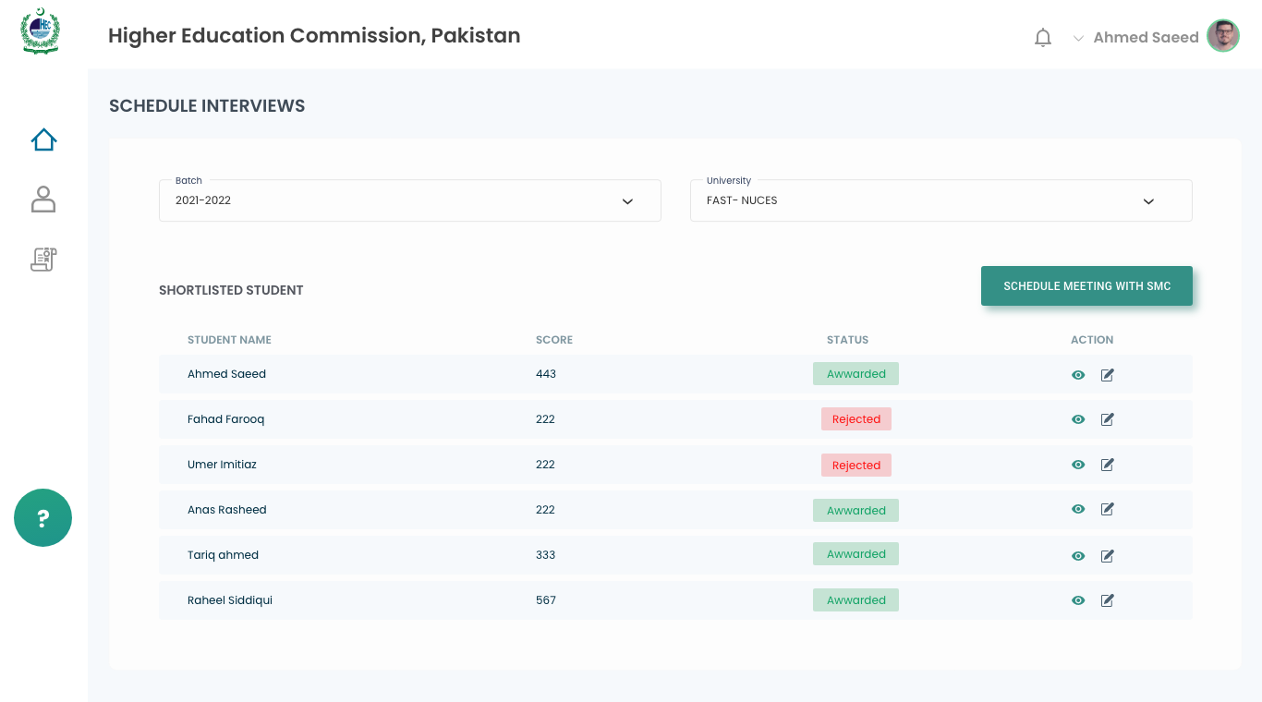
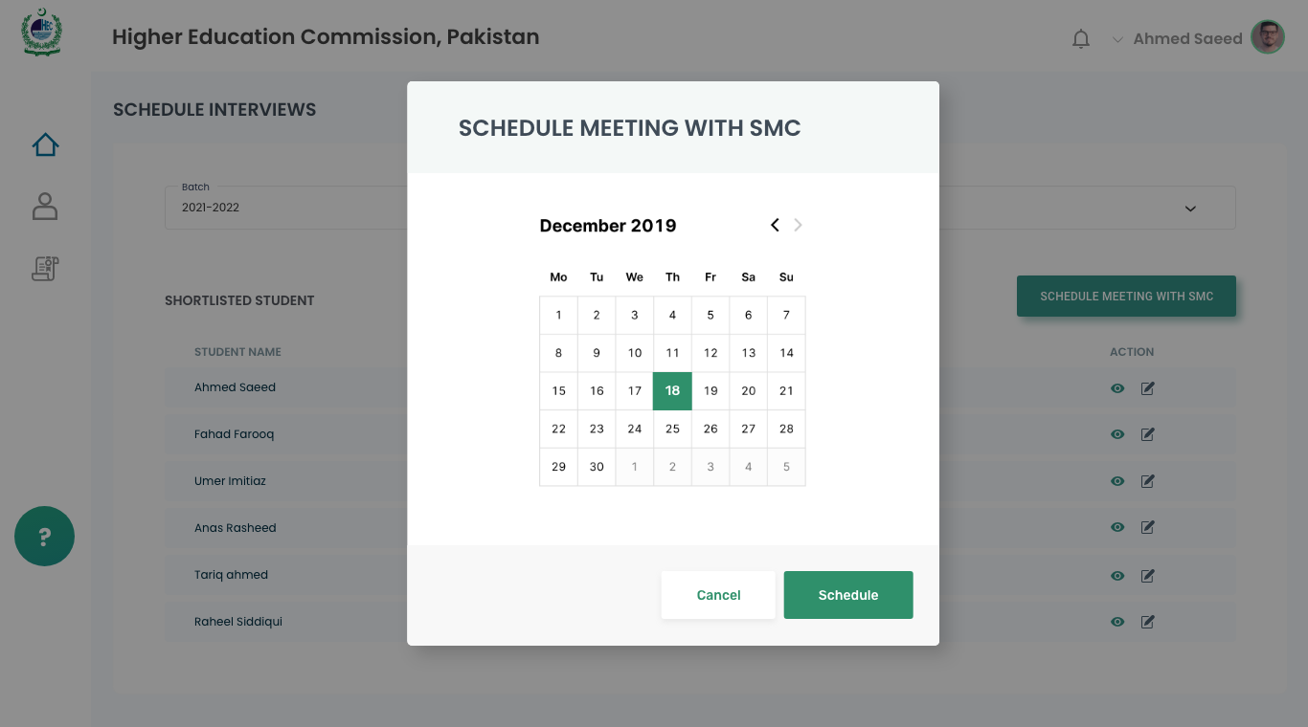
Figure 17: Schedule SMC Meeting

Email Notifications
A new screen will be added for configuring email notifications. Admin will be able to search for a list of applicants via University and Application Status search fields. Once the list of applicants will be displayed, admin can check/uncheck the applicants from the list to send out email notifications to.

Capacity Building Component

Training For Officials
A dropdown will be added to specify whether the training is for UFPs or UNIVERSITY officials.

Pre-Activity Details which will be added by the PMU

Screen Details
This screen is designed to collect pre-activity details ranging from the title of the activity to the booked venue of the activity. These details will be entered by the PMU.

Screen Fields
Field Name | Field Type | Validation | Description
Title of Training | Textbox | Mandatory | Title of the training activity.
No. of Days | Numeric | Mandatory | Total number of days to be consumed by the training activity.
Names of Trainers/Resource Persons | Textbox | Mandatory | Names of the trainers/resource persons of the activity.
Agency of Trainers/Resource Persons | Textbox | Mandatory | Name of Agency from where Trainers/Resource Persons are to be outsourced.
Date of Activity | Datepicker | Mandatory | Date when the activity will be performed.
Approved budget of the Activity | Textbox | Mandatory | Total amount of budget that was approved for the activity.
Venue of the Activity | Textbox | Mandatory | Venue where the activity will take place.

Post-Activity Details which will be added by the PMU

Screen Details
This screen is designed to collect post-activity details that will be entered by the PMU.

Screen Fields
Field Name | Field Type | Validation | Description
No of Male Participants | Numeric | Mandatory | Number of Males who participated in the activity.
No of Female Participants | Numeric | Mandatory | Number of Females who participated in the activity.
Name of University | Textbox | Mandatory | Name of university of the training participants.
City of the University | Dropdown | Mandatory | Name of city of the university from where participants have attended the training.
Province of the University | Dropdown | Mandatory | Name of province of the university from where participants have attended the training.

Upload Training Pictures

Screen Details
This screen is designed for uploading the pictures from the training event.

Upload List of Participants in Excel

Screen Details
This screen is designed to upload the excel file containing the list of individuals who participated in the training.

Upload Approved Program Layout with Course Content in word

Screen Details
This screen is designed to upload a word file detailing the approved program layout and course content.

Capacity Building Activity Status

Screen Details
This screen is designed to collect details about the status of the activity.

Screen Fields
Field Name | Field Type | Validation | Description
Category | Checkbox | Mandatory | Category of the training.  Values:  - Capacity Building for Financial Aid Offices  - Capacity Building for -MNBSP Awardees  - Talent Hunt Program
Title of Training | Textbox | Mandatory | Title of the training.
Status | Dropdown | Mandatory | Status of the training activity.  Values:  - Done  - Pending  - Rescheduled  - Cancelled
Reasons: for Pending, Rescheduling and Cancelled | Textarea | Mandatory | Reason for cancellation or delay of the planning activity.

Training For Students

Pre-Activity Details which will be added by the PMU

Screen Details
This screen is designed to collect pre-activity details ranging from the title of the activity to the booked venue of the activity. These details will be entered by the PMU.

Screen Fields
Field Name | Field Type | Validation | Description
Title of Training | Textbox | Mandatory | Title of the training activity.
No. of Days | Numeric | Mandatory | Total number of days to be consumed by the training activity.
Names of Trainers/Resource Persons | Textbox | Mandatory | Names of the trainers/resource persons of the activity.
Agency of Trainers/Resource Persons | Textbox | Mandatory | Name of Agency from where Trainers/Resource Persons are to be outsourced.
Date of Activity | Datepicker | Mandatory | Date when the activity will be performed.
Approved budget of the Activity | Textbox | Mandatory | Total amount of budget that was approved for the activity.
Venue of the Activity | Textbox | Mandatory | Venue where the activity will take place.

Post-Activity Details which will be added by the PMU

Screen Details
This screen is designed to collect post-activity details that will be entered by the PMU.

Screen Fields
Field Name | Field Type | Validation | Description
No of Male Participants | Numeric | Mandatory | Number of Males who participated in the activity.
No of Female Participants | Numeric | Mandatory | Number of Females who participated in the activity.
Name of University | Textbox | Mandatory | Name of university of the training participants.
City of the University | Dropdown | Mandatory | Name of city of the university from where participants have attended the training.
Province of the University | Dropdown | Mandatory | Name of province of the university from where participants have attended the training.

Upload Training Pictures

Screen Details
This screen is designed for uploading the pictures from the training event.

Upload List of Participants in Excel

Screen Details
This screen is designed to upload the excel file containing the list of individuals who participated in the training.

Upload Approved Program Layout with Course Content in word

Screen Details
This screen is designed to upload a word file detailing the approved program layout and course content.

Capacity Building Activity Status

Screen Details
This screen is designed to collect details about the status of the activity.

Screen Fields
Field Name | Field Type | Validation | Description
Category | Checkbox | Mandatory | Category of the training.  Values:  - Capacity Building for Financial Aid Offices  - Capacity Building for -MNBSP Awardees  - Talent Hunt Program
Title of Training | Textbox | Mandatory | Title of the training.
Status | Dropdown | Mandatory | Status of the training activity.  Values:  - Done  - Pending  - Rescheduled  - Cancelled
Reasons: for Pending, Rescheduling and Cancelled | Textarea | Mandatory | Reason for cancellation or delay of the planning activity.

Talent Hunt Program

Pre-Activity Details which will be added by the PMU

Screen Details
This screen is designed to collect pre-activity details ranging from the title of the activity to the booked venue of the activity. These details will be entered by the PMU.

Screen Fields
Field Name | Field Type | Validation | Description
Title of Training | Textbox | Mandatory | Title of the training activity.
No. of Days | Numeric | Mandatory | Total number of days to be consumed by the training activity.
Names of Trainers/Resource Persons | Textbox | Mandatory | Names of the trainers/resource persons of the activity.
Agency of Trainers/Resource Persons | Textbox | Mandatory | Name of Agency from where Trainers/Resource Persons are to be outsourced.
Date of Activity | Datepicker | Mandatory | Date when the activity will be performed.
Approved budget of the Activity | Textbox | Mandatory | Total amount of budget that was approved for the activity.
Venue of the Activity | Textbox | Mandatory | Venue where the activity will take place.
Activity Launched in Partnership | Textbox | Mandatory | Name of the university in which PMU has collaborated to start the activity.

Post-Activity Details which will be added by the PMU

Screen Details
This screen is designed to collect post-activity details that will be entered by the PMU.

Screen Fields
Field Name | Field Type | Validation | Description
No of Female Participants | Numeric | Mandatory | Number of Females who participated in the program.
Degree Level of Participants | Dropdown | Mandatory | Degree level of the participants of the program.  Values:  - Matric  - Intermediate
Domicile of the Participants | Dropdown | Mandatory | Domicile of the participants of the program.
Province of the Participants | Dropdown | Mandatory | Province of the participants of the program.

Upload Training Pictures

Screen Details
This screen is designed for uploading the pictures from the training event.

Upload List of Participants in Excel

Screen Details
This screen is designed to upload the excel file containing the list of individuals who participated in the training.

Upload Approved Program Layout with Course Content in word

Screen Details
This screen is designed to upload a word file detailing the approved program layout and course content.

Capacity Building Activity Status

Screen Details
This screen is designed to collect details about the status of the activity.

Screen Fields
Field Name | Field Type | Validation | Description
Category | Checkbox | Mandatory | Category of the training.  Values:  - Capacity Building for Financial Aid Offices  - Capacity Building for -MNBSP Awardees  - Talent Hunt Program
Title of Training | Textbox | Mandatory | Title of the training.
Status | Dropdown | Mandatory | Status of the training activity.  Values:  - Done  - Pending  - Rescheduled  - Cancelled
Reasons: for Pending, Rescheduling and Cancelled | Textarea | Mandatory | Reason for cancellation or delay of the planning activity.

Training Calendar
A training calendar module will be added that will be used to schedule training events more efficiently. The Admin will be able to record dates against different training events that are scheduled as a part of scholarship programs.

Screen Fields
Field Name | Field Type | Validation | Description
Workshop Title | Textbox | Mandatory | Title of the workshop being scheduled.
Starting From | Datepicker | Mandatory | Starting date of the workshop.
To | Datepicker | Mandatory | Ending date of the workshop.
No. of Days | Read-only |  | Total number of days as calculated from starting and ending date.

APPENDIX B – EMAIL TEMPLATES

Email message to applicant after receiving online application

Dear Applicant,
Reference to your application vide Ref No.------------------------------------------------------------ submitted for the Pak- Merit & Needs Based Scholarship Program has been successfully received.
Please print filled application form, attach required documents and send to the relevant partner university/institution.
No reply is needed for this email.

Deficiency of Documents (If any). Before interview, FAO verifies documents and email to applicant for the submission of the deficiencies in application

Dear Applicant,
Reference to your application vide Ref No.------------------------------------------------------------ submitted for the Pak- Merit & Needs Based Scholarship Program, the following documents are missing.

Sr# | Name of Document

Please submit the above mentioned documents before ---------------------------------------------in the office of the Directorate of Financial Aid of relevant partner Universities/Institutions.
In case you fail to submit the above mentioned documents within due date, your application will be rejected.

Call for Interview (For applicant appearance for interview before Institutional Scholarship Award Committee)

Dear Applicant,
Reference to your application vide Ref No.------------------------------------------------------------ submitted for the Pak- Merit & Needs Based Scholarship Program, your interview will be held on --------------------------------- at ------------------------ in the office of the Director, Financial Aid/ Video Conference Hall.
Please bring your original documents of which copies were provided by you and attached with your application at time of submission or provided after that in the office of the Director, Financial Aid Office.
Please note if you do not bring original documents, you may be rejected.
You are requested, please reach in the above mentioned office and date and time as mentioned above.

ISAC Decision (after the interview of applicants)

Dear Applicant,
Reference to your application vide Ref No. submitted for the Pak- Merit & Needs Based Scholarship Program, you appeared for interview held on ------------------------------------------------------
The recommendations have been forwarded to the competent authority for approval and result will be conveyed to you via email.
Thanks for interest in Pak- Merit & Needs Based Scholarship Program.

SMC Decision (Selection of candidates for scholarships)

Dear applicant,
Reference to your application vide Ref No. submitted for the Pak- Merit & Needs Based Scholarship Program, you have been selected for the Pak- scholarship.
Please contact Financial Aid Office in relevant partner University/Institution for further details.

Estimations:
The effort of development lifecycle is estimated to be 1268 hours which amount to be PKR 3,696,761.5 as per the signed off contract.

Phase 1
University Focal Person | FE | BE | DB | QA | Total
Role Management | 5 | 7 | 1.5 | 3 | 16.5
Search Apps (filters) | 12 | 12 | 0 | 3 | 27
Application List (Submitted Apps) | 11 | 13 | 1.5 | 6 | 31.5
Score Calculation | 6 | 12 | 6 | 10 | 34
Pre ISAC | 7 | 12 | 0 | 3 | 22
Schedule Interview | 9 | 3 | 0 | 3 | 15
Send interview Email (Fixed template) | 3 | 3 | 0 | 1.5 | 7.5
Submit Interview Result | 16 | 12 | 1.5 | 6 | 35.5
Download Excel | 3 | 20 | 6 | 9 | 38
Email Interview Result to SMC (fixed template) | 1.5 | 3 | 0 | 1.5 | 6
Total | 73.5 | 97 | 16.5 | 46 | 233

Phase 2
SMC
Role Management | 9 | 9 | 1 | 4.5 | 23.5
Search Apps | 6 | 14 | 0 | 3 | 23
Application List (Approve/Waiting UFP) | 9 | 14 | 0 | 6 | 29
Schedule Interview with UfP | 6 | 6 | 0 | 1.5 | 13.5
Email UFP for Interview(fixed template) | 1.5 | 1.5 | 0 | 1.5 | 4.5
Update result | 9 | 16 | 1.5 | 6 | 32.5
Update Status (Awardee to Reject/Waiting to Awardee) | 4 | 6 | 0 | 3 | 13
Email Awardee Applicant | 1 | 3 | 0 | 2 | 6
Total | 45.5 | 69.5 | 2.5 | 27.5 | 145

Physical Verification
Application list(Approved from SMC) | 6 | 11 | 3 | 5 | 25
Verification Needed/Not Needed | 6 | 2 | 0 | 2 | 10
Upload Verification Document | 9 | 1.5 | 1.5 | 3 | 15
Update Verification Result | 6 | 12 | 1 | 5 | 24
Total | 27 | 26.5 | 5.5 | 15 | 74

Phase 3
Invoice Generation
Application List (Awardee) | 8 | 8 | 0 | 5 | 21
Update Academic Info | 6 | 14 | 1 | 5 | 26
Update Status (Freeze/Dropped etc.) | 6 | 8 | 0 | 4 | 18
Update Expense Details | 8 | 8 | 1 | 4 | 21
Student Expense History | 4 | 12 | 2 | 4 | 22
Invoice History | 6 | 8 | 1 | 5 | 20
Total | 38 | 58 | 5 | 27 | 128

PMU Finance
Accept Reject Invoice | 4 | 6 | 0 | 3 | 13
Calculate Fee, Download and Generate Invoice Excel | 6 | 16 | 2 | 6 | 30
Request Invoice Revision | 5 | 4 | 1 | 3 | 13
Update Grant Transfer Detail | 4 | 4 | 0 | 3 | 11
Upload Evidence Document | 4 | 1 | 0 | 2 | 7
Total | 23 | 31 | 3 | 17 | 74

Admin Dashboard
Search by CNIC, Name, University, Batch | 6 | 8 | 0 | 3 | 17
Search Results on basis of criteria | 8 | 8 | 0 | 2 | 18
Graphical Dashboard | 13 | 13 | 2 | 6 | 34
Total | 27 | 29 | 2 | 11 | 69

Configuration Screen
Batch Config (Add/Edit/View Batch Details) | 12 | 9 | 0 | 4 | 25
Scholarship Config (Add/Edit/View Scholarship Details) | 12 | 9 | 0 | 4 | 25
University Config (Add/Edit/View University) | 8 | 10 | 0 | 6 | 24
Degree Program Config (Add/Edit/View Degree Prog) | 8 | 8 | 1 | 4 | 21
Discipline Config (Add/Edit/View Discipline) | 9 | 9 | 0 | 5 | 23
Quota Config (Add/Edit/View Quota) | 8 | 8 | 0 | 3 | 19
Configure Scoring Criteria | 8 | 8 | 2 | 3 | 21
Total | 65 | 61 | 3 | 29 | 158

Email Notifications
Select Batch and Scholarship | 7 | 4 | 0 | 2 | 13
Search Applications (University, Application Status) | 7 | 4 | 0 | 2 | 13
View List of Applications (View/Select) | 10 | 6 | 0 | 4 | 20
Send Email Notification to Selected Applications | 4 | 3 | 0 | 4 | 11
Total | 28 | 17 | 0 | 12 | 57

Phase 4
Capacity Building
Officials Training
Training Listing | 10 | 10 | 1 | 2 | 23
Pre Training | 9 | 10 | 1 | 3 | 23
Post Training | 8 | 8 | 1 | 2 | 19
Document Upload | 6 | 6 | 0 | 1 | 13
Status | 8 | 9 | 0 | 1 | 18
Students Training
Training Listing | 10 | 11 | 1 | 2 | 24
Pre Training | 10 | 10 | 1 | 3 | 24
Post Training | 8 | 8 | 1 | 2 | 19
Document Upload | 6 | 6 | 0 | 1 | 13
Status | 8 | 8 | 0 | 1 | 17
Talent Hunt
Training Listing | 9 | 8 | 1 | 2 | 20
Pre Training | 9 | 10 | 1 | 3 | 23
Post Training | 8 | 8 | 1 | 2 | 19
Document Upload | 6 | 6 | 0 | 1 | 13
Status | 8 | 8 | 0 | 1 | 17
Training Calendar
Training Detail | 14 | 8 | 1 | 3 | 26
Update Calendar | 10 | 7 | 0 | 2 | 19
Total | 147 | 141 | 10 | 32 | 330

UNIVERSITY IT Focal person

Focal Person Head of Business Division

